DEPARTMENT OF AVIONICS ENGINEERING

SUBJECT |  |  | : | CONTROL SYSTEMS LAB
SUBJECT CODE |  |  | : | 305312
LAB NO |  |  | : | 02

TITLE |  |  | : | IMPLEMENTATION OF DYNAMIC SYSTEMS IN SIMULINK
SUBMITTED TO |  |  | : | Ms. Anila Ali Ahmed
SEMESTER |  |  | : | 5th
SECTION |  |  | : | A
Marks Obtained
 | Group Member 1 |  |  |  | Group Member 2 | Group Member 3
NAME
REGISTRATION #
LAB REPORT
PERFORMANCE
TOTAL MARKS
DEADLINE: |  | 1100 Hrs, 14th October 2024
DATE OF SUBMISSION:

Title: IMPLEMENTATION OF DYNAMIC SYSTEMS IN SIMULINK

- Mathematical Modeling of Physical Systems
- Implementation in Simulink

During this course a sequence of experiments treating the step-by-step design and test procedures for typical classical controllers will be performed. Here we encounter a valuable tool: simulation. Simulation is a means of predicting the quantitative and qualitative behavior of a physical system by using a mathematical model of the system. Often it is impractical to design a controller for a specific piece of equipment without careful preliminary testing. For example, an incorrectly designed process controller for a paper or chemical manufacturing plant could result in a cost of millions in damage. A faulty auto-pilot for a commercial aircraft could likewise cost in money as well as lives. Therefore, with the exception of simple isolated systems, we seldom design and test controllers on systems directly. Rather, a mathematical model of a dynamic system is constructed, and then somehow simulated.
That is, the system’s time response is predicted for arbitrary inputs. For many cases the simulation phase can be done by means of digital computers, particularly when high numerical accuracy is required. We will be using Simulink: a simulation package that operates inside of Matlab. With Simulink, a model of the system is first defined in block-diagram form, and then it is analyzed by injecting signals and observing the outcome.

Simulink is a powerful graphical user interface (GUI) of Matlab. This software is used for solving the modeling equations and obtaining the response of a system to different inputs. Both linear and nonlinear differential equations can be solved numerically with high precision and speed, allowing system responses to be calculated and displayed for many input functions. To provide an interface between a system’s modeling equations and the digital computer, block diagrams drawn from the system’s differential equations are used. A block diagram is an interconnection of blocks representing basic mathematical operations in such a way that the overall diagram is equivalent to the system’s mathematical model. The lines interconnecting the blocks represent the variables describing the system behavior. These may be inputs, outputs, state variables, or other related variables. The blocks represent operations or functions that use one or more of these variables to calculate other variables. Block diagrams can represent modeling equations in both input-output and state variable form.
The operations that we generally use in block diagrams are summation, gain, and integration. Other blocks, including nonlinear elements such as multiplication, square root, exponential, logarithmic, and other functions, are available. Provisions are also included for supplying input functions, using a signal generator block, constants etc and for displaying results, using a scope block.
An important feature of a numerical simulation is the ease with which parameters can be varied and the results observed directly. MATLAB is used in a supporting role to initialize parameter values and to produce plots of the system response. Also MATLAB is used for multiple runs for varying system parameters.

SIMULINK

Simulink provides access to an extensive set of blocks that accomplish a wide range of functions useful for the simulation and analysis of dynamic systems. The blocks are grouped into libraries, by general classes of functions.

• Mathematical functions such as summers and gains are in the Math library.
• Integrators are in the Continuous library.
• Constants, common input functions, and clock can all be found in the Sources library.
• Scope, To Workspace blocks can be found in the Sinks library.

Simulink allows the user to create programs that are actually run in MATLAB. When these programs run, they create arrays of the variables defined in Simulink that can be made available to MATLAB for analysis and/or plotting. The variables to be used in MATLAB must be identified by Simulink using a “To Workspace” block, which is found in the Sinks library. (When using this block, open its dialog box and specify that the save format should be Matrix, rather than the default, which is called Structure.) The Sinks library also contains a Scope, which allows variables to be displayed as the simulated system responds to an input. This is most useful when studying responses to repetitive inputs.
Simulink uses blocks to write a program. Blocks are arranged in various libraries according to their functions. Properties of the blocks and the values can be changed in the associated dialog boxes. Some of the blocks are given below.

SUM (Math library)
A dialog box obtained by double-clicking on the SUM block performs the configuration of the Sum block, allowing any number of inputs and the sign of each. The sum block can be represented in two ways in Simulink, by a circle or by a rectangle. Both choices are shown

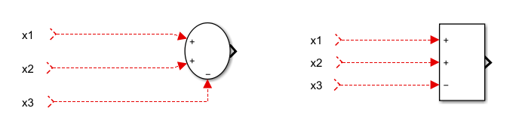

Figure 1: Two Simulink blocks for a summer representing y = x 1+ x2 – x3

GAIN (Math library)
A gain block is shown by a triangular symbol, with the gain expression written inside if it will fit. If not, the symbol - k - is used. The value used in each gain block is established in a dialog box that appears if the user double-clicks on its block.

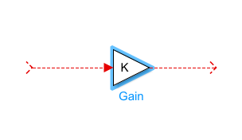

Figure 2: Simulink block for a gain of K.

INTEGRATOR (Continuous library)
The block for an integrator as shown below looks unusual. The quantity 1/s comes from the Laplace transform expression for integration. When double-clicked on the symbol for an integrator, a dialog box appears allowing the initial condition for that integrator to be specified. Initial conditions may be specific numerical values, literal variables, or algebraic expressions.

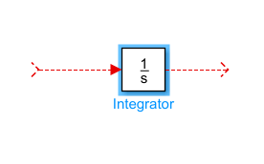

Figure 3: Simulink block for an integrator.

CONSTANTS (Source library)
Constants are created by the Constant block, which closely resembles Figure 4. Double- clicking on the symbol opens a dialog box to establish the constant’s value. It can be a number or an algebraic expression using constants whose values are defined in the workspace and are therefore known to MATLAB.

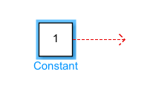

Figure 4: A constant block
STEP (Source library)
A Simulink block is provided for a Step input, a signal that changes (usually from zero) to a specified new, constant level at a specified time. These levels and time can be specified through the dialog box, obtained by double-clicking on the Step block.

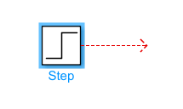

Figure 5: A step block

SIGNAL GENERATOR (Source library)
One source of repetitive signals in Simulink is called the Signal Generator. Double-clicking on the Signal Generator block opens a dialog box, where a sine wave, a square wave, a ramp (sawtooth), or a random waveform can be chosen. In addition, the amplitude and frequency of the signal may be specified. The signals produced have a mean value of zero. The repetition frequency can be given in Hertz (Hz), which is the same as cycles per second, or in radians/second.

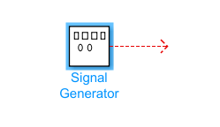

Figure 6: A signal generator block

SCOPE (Sinks library)
The system response can be examined graphically, as the simulation runs, using the Scope block in the sinks library. This name is derived from the electronic instrument, oscilloscope, which performs a similar function with electronic signals. Any of the variables in a Simulink diagram can be connected to the Scope block, and when the simulation is started, that variable is displayed. It is possible to include several Scope blocks. Also it is possible to display several signals in the same scope block using a MUX block in the signals routing library. The Scope normally chooses its scales automatically to best display the data.

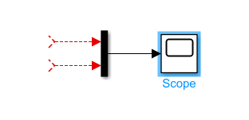

Figure 7: A scope block with MUX block

Two additional blocks will be needed if we wish to use MATLAB to plot the responses versus time. These are the Clock and the To Workspace blocks.

CLOCK (Sources library)
The clock produces the variable “time” that is associated with the integrators as MATLAB calculates a numerical (digital) solution to a model of a continuous system. The result is a string of sample values of each of the output variables. These samples are not necessarily at uniform time increments, so it is necessary to have the variable “time” that contains the time corresponding to each sample point. Then MATLAB can make plots versus “time.” The clock output could be given any arbitrary name; we use “t” in most of the cases.

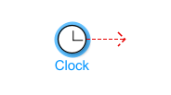
Figure 8: A clock block

To Workspace (Sinks library)
The To Workspace block is used to return the results of a simulation to the MATLAB workspace, where they can be analyzed and/or plotted. Any variable in a Simulink diagram can be connected to a ToWorkspace block. In our exercises, all of the state variables and the input variables are usually returned to the workspace. In addition, the result of any output equation that may be simulated would usually be sent to the workspace. In the block parameters drop down window, change the save format to ‘array’.

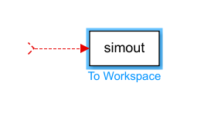

Figure 9: A To Workspace block

In the Simulink diagram, the appearance of a block can be changed by changing the foreground or background colours, or by drop shadow or other options available in the format drop down menu. The available options can be reached in the Simulink window by highlighting the block, then clicking the right mouse button. The Show Drop Shadow option is on the format drop-down menu.

You are encouraged to browse the Simulink libraries and consult the online Help facility provided with MATLAB.

MASS SPRING DAMPER SYSTEM EXAMPLE

In class we have learned how to model different physical systems. Consider the mass spring damper system shown in Figure 10.
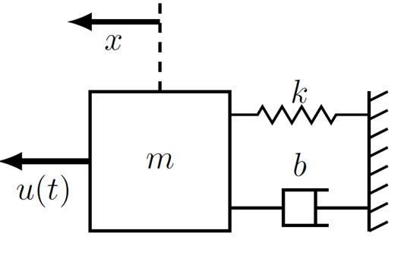
Figure 10: Mass, spring, damper system

The equation of motion describing the systems can be written as

$$m\ddot{x}=u\left(t\right)-b\dot{x}-kx$$

Where m is the mass, b is the damper, and k is the spring constant. For instance we take the following values

$$m=10kg$$
$$b=2Nsm^{-1}$$
$$k=5Nm^{-1}$$

x is the position displacement, $\dot{x}$ is the time derivative of position i.e., velocity and $\ddot{x}$ is the acceleration of the mass
The above equation can be re-written as

$$10\ddot{x}=u\left(t\right)-2\dot{x}-5x$$

Now this equation is to be implemented in Simulink with a unit step input, and position of the mass taken as the output.
IMPLEMENTATION IN SIMULINK
To create a simulation in Simulink, follow the steps:

- Start MATLAB.
- Start Simulink. Type Simulink in the command window and press enter.
- This will open the Simulink start page. Click on Blank model.

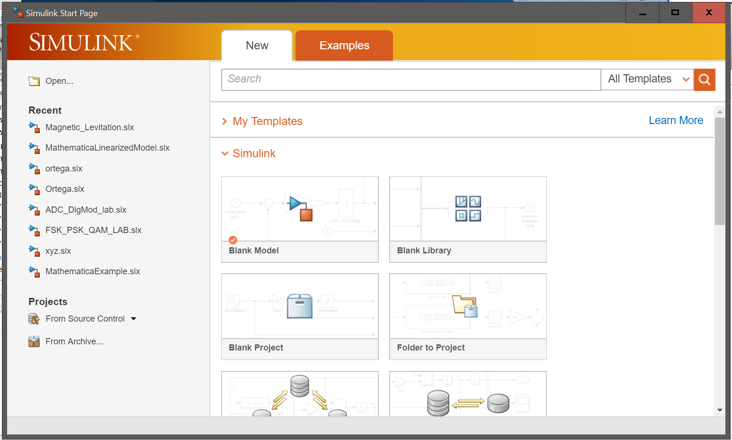

- Following window will appear. Click on the highlighted icon to open Simulink library browser.

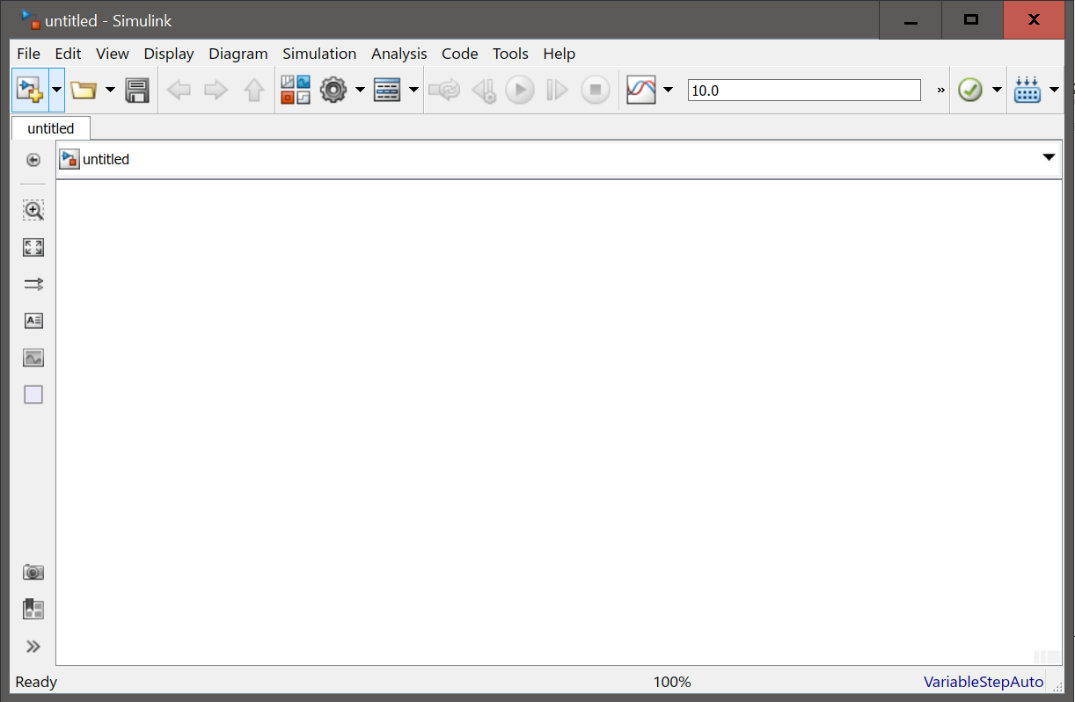
- Open the libraries that contain the blocks you will need. These usually will include the Sources, Sinks, Math and Continuous libraries, and possibly others.
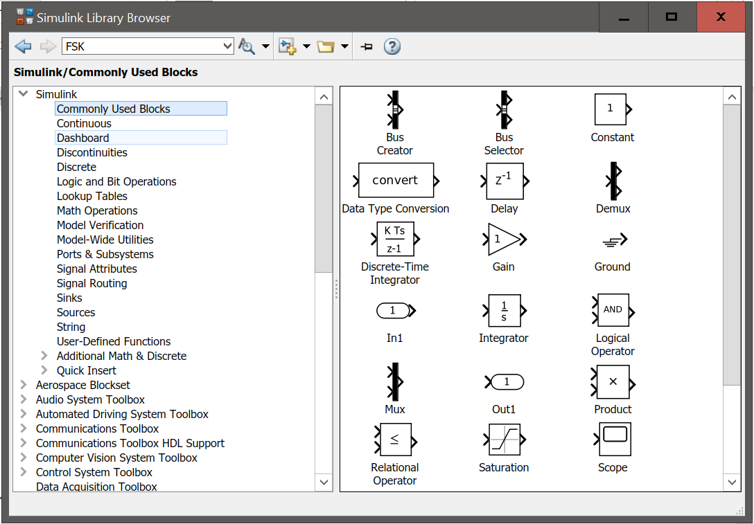

- Write sum in the search bar. Drag the block to the Simulink window. Similarly drag following blocks to the Simulink window.

  - Step
  - Integrator
  - Gain
  - Scope

- To duplicate any block, click on the block, press ctrl and while keeping it pressed, drag the block. This would add an identical block. In the current case, do this twice for the Gain block and once for the Integrator block. This would add 1 integrator block and 2 gain blocks.
- To flip any block, select the block and press ctrl+I OR right click on the block and in the Rotate and Flip tab select Flip Block. Similarly, to rotate any block, press ctrl+R OR right click on the block and in the Rotate and Flip tab select Clockwise or Counterclockwise. In the current case, flip two Gain blocks and leave one as it is.
- Arrange these blocks in an orderly way corresponding to the equations to be solved. To arrange the blocks you must understand the equation. The equation is given as
$$mẍ = u(t) - bẋ - kx$$
This means that the result of the Sum block is $mẍ$ and there are 3 inputs to the Sum block i.e. 𝑢(𝑡), $-bẋ$, 𝑎nd $–kx$. To implement this, double click on the Sum block and in the List of Signs section, enter 1 ‘+’ sign and 2 ‘-‘ signs as shown in the figure below.

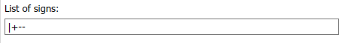

Now, connect the Step block to the ‘+’ sign input of the Sum block. We know that the output of the Sum block is $m\ddot{x}$, so to obtain $\ddot{x}$, we will Multiply this output with a factor $1/m$. This is done by using the Gain block. Connect the output of the Sum block to the input of the Gain block (which is not flipped). Double click on the Gain block, and under the Gain section write ‘$1/m$’. The output of this Gain block is giving $\ddot{x}$. To produce $\dot{x}$, from $\ddot{x}$, the Integrator block will be used. Connect the output of this Gain block to the input of one Integrator block. Again, to produce $x$ from $\dot{x}$, an Integrator block will be used. Connect the output of the first Integrator block to the input of the second Integrator block. The output of the second Integrator block is giving $x$. Since in the current case, we are interested in observing the distance covered by the mass. So connect the output of the second Integrator block to the Scope block (If you want to observe the velocity, you can connect the output of the 1st Integrator block to another Scope block. The two negative inputs of the Sum block are still to be connected. We know that the one of the inputs to the Sum block is $-b\dot{x}$, so to obtain this term, connect the input of one flipped Gain block to the output of the first Integrator block which is actually $\dot{x}$. Double click on this Gain block and under the Gain section write ‘$b$’. The output of this Gain block is $b\dot{x}$. Connect this output to one of the negative inputs of the Sum block. Similarly, we know that the second input to the Sum block is −𝑘𝑥, so to obtain this term, connect the input of the second flipped Gain block to the output of the second Integrator block which is actually 𝑥. Double click on this Gain block and under the Gain section write ‘k’. The output of this Gain block is 𝑘𝑥. Connect this output to the only unconnected input of the Sum block.
- Interconnection of the blocks is done by dragging the cursor from the output of one block to the input of another block. Interconnecting branches can be made by right-clicking on an existing branch.
- Double-click on any block having parameters that must be established, and set these parameters. For example, the gain of all Gain blocks must be set. The number and signs of the inputs to a Sum block must be established. The parameters of any source blocks should also be set in this way.
- The block diagram should look like following

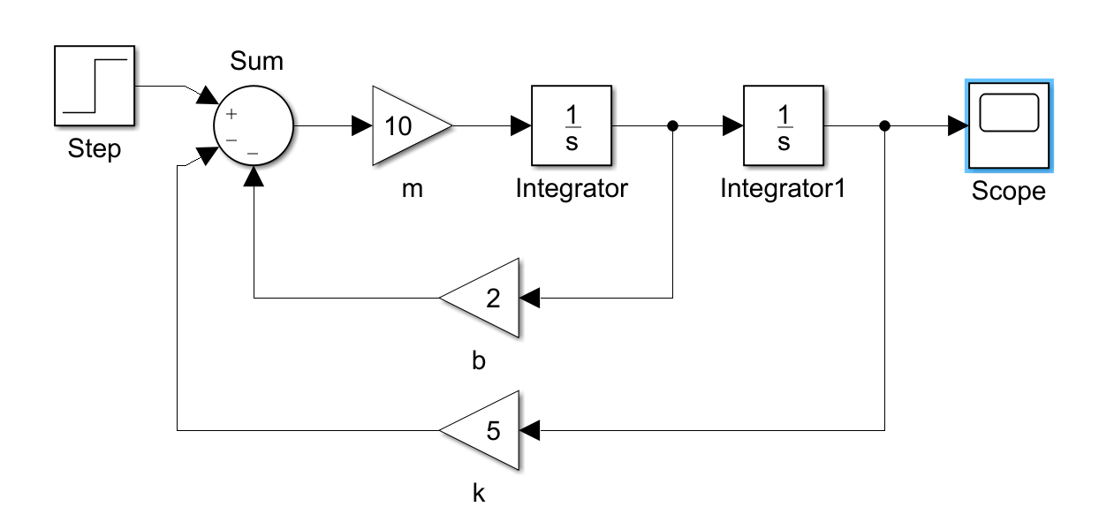

Figure 11: Block Diagram

- Double click on the 1st Integrator block. You can give an initial velocity value by editing the value under the Initial Value section. However, for the current case, we consider the initial velocity to be 0 𝑚/s and the default value under the Initial Value section is also 0. Similarly, Double click on the 2nd Integrator block. You can give an initial position value by editing the value under the Initial Value section. However, for the current case, we consider the initial position to be 0 𝑚 and the default value under the Initial Value section is also 0. This completes the implementation.
- The model is ready to be simulated now. The simulation time can be changed, by editing the time in the model window as highlighted (green color) in the figure below:

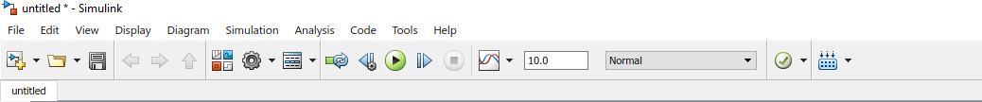

- To run the simulation, press the run button as highlighted (red color) in the above figure.
- To observe the position plot, Double Click on the Scope block.
- It is necessary to specify a stop time for the solution. This is done by clicking on the Simulation > Parameters entry on the Simulink toolbar.
- At the Simulation > Parameters entry, several parameters can be selected in this dialog box, but the default values of all of them should be adequate for almost all of the exercises. If the response before time zero is needed, it can be obtained by setting the Start time to a negative value. It may be necessary in some problems to reduce the maximum integration step size used by the numerical algorithm. If the plots of the results of a simulation appear “choppy” or composed of straight-line segments when they should be smooth, reducing the max step size permitted can solve this problem.

Questions for Lab Report

Exercise 1:

Consider the following mass-spring damper
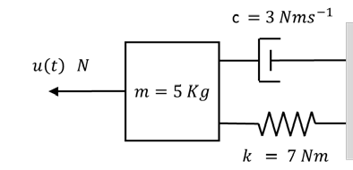

a. Model the system.
b. Solve the equation obtained in part (a) in SIMULINK and obtain the position response with a unit step input for 0 ≤ 𝑡 ≤ 50 𝑠.

Exercise 2:

Consider the following mass-spring damper

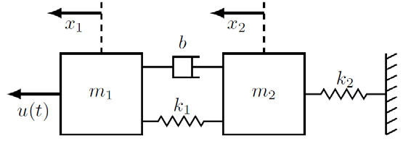

Initial Conditions: $x_{1}\left(0\right)=x_{2}\left(0\right)={\dot{x}}_{1}\left(0\right)={\dot{x}}_{2}\left(0\right)=0$
$$m_{1}=m_{2}=\left(\frac{N}{100}+1\right)kg$$
$$k_{1} = 7.5 Nm^{-1}$$
$$k_{2} = 35 Nm^{-1}$$
$$b=\left(\frac{N}{100}+0.6\right)Nsm^{-1}$$

where 𝑁 is the mean/average of the last two digits of the registration number of the individual student.

- Model the system.
- Implement the system in SIMULINK with unit step input at 𝑡 = 0 and obtain graphs for $x_{1}$ and $x_{2}$ with time separately (0 ≤ 𝑡 ≤ 20).

OBE ASSEMENT

CLO statement | Level | Marks
CLO-1: Model given dynamical system in MATLAB & SIMULINK and analyze its transient and steady-state characteristics via simulations. | P-3, C-4

